

# Xplore 8 Days Namibia

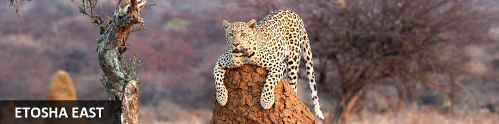

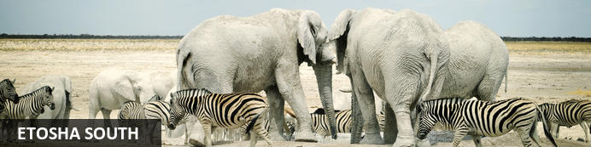

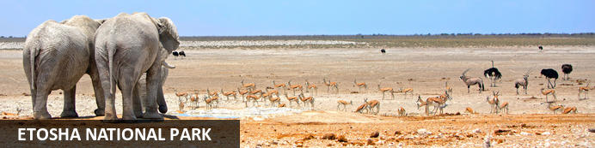

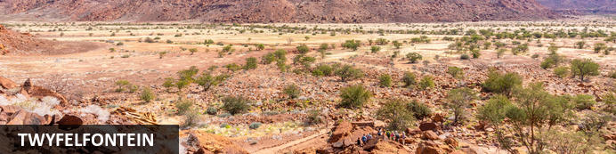

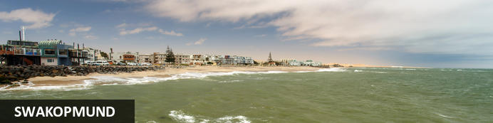

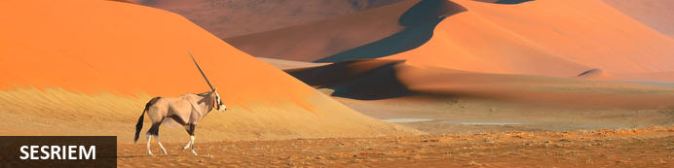

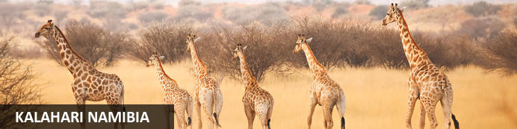

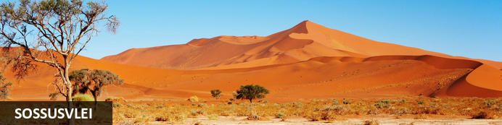

# Xplore 8 Days Namibia

*Etosha East - Etosha South - Etosha National Park - Twyfelfontein - Swakopmund - Sesriem - Kalahari Namibia - Sossusvlei*  
*8 Days / 7 Nights*  
*2 Persons*  
*Date of Issue: 25 February 2025*

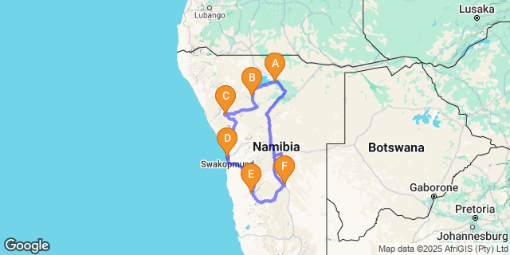

# [Click here to view your Digital Itinerary](https://wetu.com/Itinerary/Landing/2BDDDD04-19BB-4EEA-9619-F82BBEF3A123)

## Introduction

|  |  |  |  |  |  |
| --- | --- | --- | --- | --- | --- |
| **Start** | **Accommodation** | **Destination** | **Basis** | **Room Type** | **Duration** |
| Day 1 | [Mushara Bush Camp](https://wetu.com/iBrochure/43610_20477) | Etosha East | D,B&B | 1x Double Room | **1 Night** |
| Day 2 | [Toshari Lodge](https://wetu.com/iBrochure/43610_10559) | Etosha South | D,B&B | 1x Double Room | **1 Night** |
| Day 3 | [Twyfelfontein Adventure Camp](https://wetu.com/iBrochure/43610_203468) | Twyfelfontein | D,B&B | 1x Double Room | **1 Night** |
| Day 4 | [Swakopmund Sands Hotel](https://wetu.com/iBrochure/43610_34719) | Swakopmund | B&B | 1x Double Room | **2 Nights** |
| Day 6 | [Desert Quiver Camp](https://wetu.com/iBrochure/43610_54152) | Sesriem | B&B | 1x Double Room | **1 Night** |
| Day 7 | [Kalahari Red Dunes Lodge](https://wetu.com/iBrochure/43610_24103) | Kalahari Namibia | D,B&B | 1x Double Room | **1 Night** |

**Key**  
B&B: Bed and Breakfast  
D,B&B: Dinner, Bed and Breakfast

## Day 1: Mushara Bush Camp, Etosha East

### Etosha East

Located in Northwestern Namibia, Etosha East is a protected sanctuary in the eastern part of the world-renowned Etosha National Park, known as one of the most accessible game reserves in Southern Africa. Etosha East boasts vast open plains scattered with semi-arid savannah grasslands dotted with watering holes and secluded bush camps. An impressive 5000-square-kilometre Etosha salt pan makes up a large area of the eastern side of the park and can even be seen from space. This remote area teems with abundant wildlife such as lions, elephants, black rhinos and giraffes, as well as a variety of birdlife featuring flamingos, ostriches, eagles, hornbills, and owls.

### Overnight: Mushara Bush Camp [View iBrochure](https://wetu.com/iBrochure/43610_20477)

MUSHARA BUSH CAMP

Mushara Bush Camp is situated a mere 10 kilometers from the Von Lindequist gate of the world famous Etosha National Park. The Mushara Bush Camp offers a down-to-earth tented bush camp experience which is well suited as a basis base for independent travelers and families exploring the magical Etosha Pan National Park.

The main Bush Camp House is thatched and has a true bush camp feel to it. The early evenings see a campfire lit where guest can exchange stories of the day’s wildlife sightings. Dinner, lunch and breakfast are served on the thatched verandah with the bush being a mere step away. The Mushara Bush Camp is your optimal family destination on the doorstep to the magical Etosha National Park.

The 16 custom made en-suite tents are built from a combination of canvas, wood and local limestone. With their own 8 square metre private verandah and roof to floor windows, theses rooms are spacious and airy. Each large bathroom has an oversized window and shower looking into the surrounding bush. The brushed cement floors and lime stone walls keep the rooms cool from the afternoon sun. Four of these tents are ideally suited for families with small children as they have a  
sleeper couch for two children.

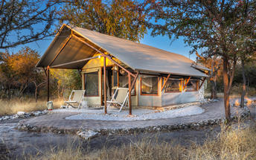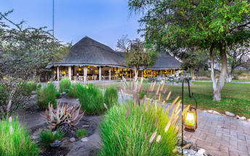

|  |
| --- |
| Directions - Hosea Kutako International Airport [WDH] to Mushara Bush Camp |
| **Distance:** 561.99km **Travel Time:** 5:33 hours |
| **GPS co-ordinates for Mushara Bush Camp:** S 18° 48' 48.928" E 17° 07' 42.866" |
| * Head southwest (1.1 km)http://schemas.openxmlformats.org/drawingml/2006/picture * Turn right (0.2 km) * Slight right (0.6 km) * Turn left (0.6 km) * Turn right onto B6 (37.1 km) * Turn right onto Sam Nujoma Dr (1.8 km) * Turn right onto Nelson Mandela Ave (3.2 km) * Turn right onto Robert Mugabe Ave (1.7 km) * At the roundabout, take the 2nd exit (0.2 km) * Continue straight (0.1 km) * Continue onto B1 (0.8 km) * Turn right onto the ramp to A1 (0.4 km) * Continue onto A1 (69.9 km) * Continue onto B1 (354 km) * Turn left (0.2 km) * Continue onto B1 (75.5 km) * Turn left onto C38 (14.7 km) |

### Basis

Dinner, Bed and Breakfast

## Day 2: Toshari Lodge, Etosha South

### Etosha South

Located just south of the boundary of Etosha National Park in northwestern Namibia, Etosha South makes up the southern region of this wild paradise. The area is comprised of a collection of world class private game reserves. The national park can be accessed via the southern entrance at Andersson’s Gate. Visitors can catch a glimpse of a variety of wildlife including: lion, giraffe, elephant, white and black rhino, and a multitude of plains game. Popular activities include: enjoying an open 4x4 safari with an expert guide, half day or full day drives with the option of a picnic lunch with wine on the full day game drive.

### Overnight: Toshari Lodge [View iBrochure](https://wetu.com/iBrochure/43610_10559)

Nestled on an outcrop of Dolomite Rocks under a canopy of Mopane and White Seringa Trees, Toshari Lodge is just a 20-minute drive from the Andersson Gate, on the edge of the magnificent Etosha National Park. This makes it the perfect destination for day trips into Etosha, whether on your own or expertly guided by us.  
  
Our rooms offer comfort and convenience, equipped with mosquito nets, air-conditioning, coffee/tea stations, and outdoor sitting areas. Enjoy delicious meals served from our Buffet and Grill area, featuring a variety of local Game Meats. Relax at our Bar with an extensive wine list, and local Wines, Gins, and Beers.  
  
For a rejuvenating experience, guests can indulge in relaxing massage sessions offered onsite. Explore our short walking trail to immerse yourself in nature, and take advantage of our guided trips to a local Himba village for a cultural encounter.  
  
With free WiFi across the property and three beautifully located swimming pools, Toshari Lodge promises an unforgettable stay in Namibia's breathtaking wilderness.

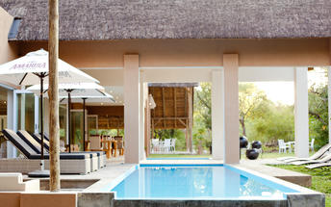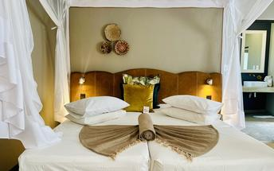

### Activities

|  |
| --- |
| Etosha Pan |

#### Etosha Pan

Aeons ago, Etosha Pan was the bed of a vast lake; today what remains is a glittering, silvery-green salt pan that stretches across roughly 5000 square kilometres. Etosha is protected by the Etosha Pan National Park surrounded by savannah plains and woodlands supporting large herds of elephants. When dry, the pan sustains little life except for the algae that gives it its distinctive colour, and migratory birds that use it as a pit stop, but with heavy rain it becomes a shallow lake where flamingos breed, pelicans wade and feed, and a variety of mammal species come to quench their thirst, including leopards, lions, white rhinos, hunting dogs and antelopes.

|  |
| --- |
| Directions - Mushara Bush Camp to Toshari Lodge |
| **Distance:** 196.97km **Travel Time:** 3:14 hours |
| **GPS co-ordinates for Toshari Lodge:** S 19° 33' 21.927" E 15° 52' 37.684" |
| * Head west on C38 (20.4 km)http://schemas.openxmlformats.org/drawingml/2006/picture * Turn left to stay on C38. Destination will be on the left (177 km) |
| *Directions supplied by Google.* |

### Basis

Dinner, Bed and Breakfast

## Day 3: Twyfelfontein Adventure Camp, Twyfelfontein

### Twyfelfontein

Set in the Kunene Region of northwestern Namibia, Twyfelfontein is a spectacularly scenic area, featuring one of the largest and most important concentrations of rock art in Africa. The name ‘Twyfelfontein’ translates to ‘Fountain of Doubt’, which refers to the perennial spring situated in the impressive Huab Valley flanked by the slopes of a sandstone table mountain. It was this spring that attracted Stone Age hunters over six thousand years ago, and it was during this time that the extensive group of rock engravings and paintings were produced. Visitors can look forward to basing themselves at some wonderfully shady campsites along the Aba-Huab riverbed, while exploring over thirty different sacred ritual sites of the traditional hunter-gatherer communities.

### Overnight: Twyfelfontein Adventure Camp [View iBrochure](https://wetu.com/iBrochure/43610_203468)

Nestled in boulders of a granite outcrop, Twyfelfontein Adventure Camp is conveniently situated only a ten minutes drive from Twyfelfontein Rock Engravings, near Damara Living Museum and within  
the Aba Huab River Valley. While the guest can choose between two different tent categories, the combined main areas with pools, restaurant, bar and lounge areas offer magnificent views of  
the mopane valley and granite mountain landscape. The sundowner spot is a sight  
not to be missed.  
  
Guests can also enjoy a scenic nature drive in the ephemeral Huab River and surrounding valley. This excursion exposes visitors to unique geological formations and the possibility of sighting the elusive desert-adapted elephants.

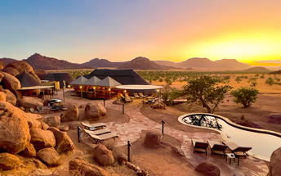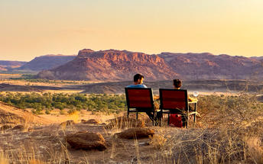

### Activities

|  |
| --- |
| Twyfelfontein Rock Art |

#### Twyfelfontein Rock Art

Twyfelfontein is a World Heritage Site boasting one of the richest rock art concentrations in Africa. Thousands of tourists come to this site each year to view some 2, 500 Stone Age rock engravings. The area is home to 17 rock art sites, which collectively encompass 212 engraved stone slabs. There are an additional 13 sites displaying rock paintings.

|  |
| --- |
| Directions - Toshari Lodge to Twyfelfontein Adventure Camp |
| **Distance:** 289.55km **Travel Time:** 3:06 hours |
| **GPS co-ordinates for Twyfelfontein Adventure Camp:** S 20° 31' 42.000" E 14° 23' 56.100" |
| * Head south on C38 toward D2695 (69.6 km)http://schemas.openxmlformats.org/drawingml/2006/picture * Turn right onto C39 (204 km) * Turn left onto D2612 (14.8 km) * Turn right onto D3254 (0.5 km) * Slight left (91 m) * Turn right (11 m) * Sharp left (0.1 km) |
| *Directions supplied by Google.* |

### Basis

Dinner, Bed and Breakfast

## Day 4: Swakopmund Sands Hotel, Swakopmund

### Swakopmund

Set along Namibia's spectacularly scenic coast, the seaside town of Swakopmund is known for its wide-open avenues, colonial architecture, and its surrounding otherworldly desert terrain. Founded in 1892 as the main harbour for German South-West Africa, Swakopmund is often described as being more German than Germany. Now a seaside resort town, Swakopmund is the capital of the Skeleton Coast tourism area and has plenty to keep visitors happy. The quirky mix of German and Namibian influences, adventure options, laid-back atmosphere and cool sea breeze make it a very popular Namibian destination. Visitors can look forward to a number of exciting activities including: quad biking, horse riding, paragliding, fishing, sightseeing and fascinating desert tours.

### Overnight: Swakopmund Sands Hotel [View iBrochure](https://wetu.com/iBrochure/43610_34719)

Located on Swakopmund’s Platinum Mile, Swakopmund Sands Hotel boasts a prime location within walking distance of the city centre, tourist attractions, restaurants, Jetty and the beach. Our accommodation offers great views, stylish comfort, top-class amenities, and warm Namibian hospitality.  
  
Start your day with a delicious breakfast and exceptional coffee from local Namibian roasters. Our rooms range from Classic, Luxury Rooms, Luxury Suites and Family Rooms, catering to all types of travelers. For small groups or self-drive clients, the Swakopmund Sands Cottage provides a cozy alternative with an amazing view of the Jetty.  
  
Our newest addition is an intimate in-house bar area, perfect for pre-dinner or sundowner drinks. Guests can also enjoy relaxing on-site massage treatments, ensuring a rejuvenating stay. Experience the best of Swakopmund with comfort and convenience at Swakopmund Sands Hotel.

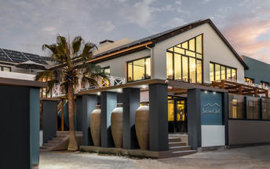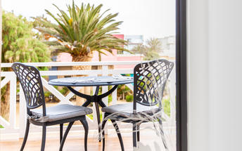

### Activities

|  |
| --- |
| Cape Cross Seal Colony |
| Zeila Shipwreck |

#### Cape Cross Seal Colony

This colony of Cape Fur Seals is one of the largest in the world, home to approximately 80 000 to 100 000 of these so-called 'seals', which are in fact a species of sea lion. Day trips to the colony are offered and the seals can be viewed from a walkway at a distance of roughly 200 metres.

#### Zeila Shipwreck

Situated on Namibia's Skeleton Coast, the Zeila Shipwreck was a fishing trawler that was sold as scrap metal to an Indian company. Unfortunately, the ship

|  |
| --- |
| Directions - Twyfelfontein Adventure Camp to Swakopmund Sands Hotel |
| **Distance:** 326.12km **Travel Time:** 4:08 hours |
| **GPS co-ordinates for Swakopmund Sands Hotel:** S 22° 41' 6.549" E 14° 31' 24.530" |
| * Head southwest (0.1 km)http://schemas.openxmlformats.org/drawingml/2006/picture * Slight left toward D3254 (71 m) * Turn right onto D3254 (0.7 km) * Turn right onto D2612 (61.8 km) * Turn right onto C35 (70.1 km) * Turn right onto C35/M76 (115 km) * Turn left onto C34/D2301. Continue to follow C34 (4.4 km) * Turn right to stay on C34 (0.6 km) * Turn left to stay on C34 (62.9 km) * Turn right to stay on C34 (7.9 km) * At the roundabout, take the 2nd exit (76 m) * Continue onto Henties Bay Rd/Nordring (0.6 km) * Turn right onto Mittel St/Tobias Hainyeko. Continue to follow Tobias Hainyeko (2.0 km) * Turn right onto Swakop St (0.3 km) * Turn left onto Am Zoll/Strand St (0.1 km) * Turn left. Destination will be on the left (23 m) |
| *Directions supplied by Google.* |

### Basis

Bed and Breakfast

## Day 5: Swakopmund Sands Hotel, Swakopmund

### Activities

|  |
| --- |
| Sandwich Dune Tours and Safari Marine Dune Combo |

#### Sandwich Dune Tours and Safari Marine Dune Combo

Sandwich Dune Tours and Safari Marine Dune Combo offer adventurers the opportunity to explore the Atlantic Ocean onboard a catamaran cruise. Participants will be able to view marine animals such as pelicans, seals, old shipwrecks and Benguela dolphins. After the cruise, the dune drive tour will commence from Sandwich Dune Tours and Safari offices at Walvis Bay Waterfront. Here, participants will meet their guide, drive to Walvis Bay Lagoon, and continue to the large salt evaporation ponds. The tour will then finally head to Kuiseb Delta, a dry riverbed where animals such as springbok frequently seek water and food.

### Basis

Bed and Breakfast

## Day 6: Desert Quiver Camp, Sesriem

### Sesriem

As there is no accommodation at Sossusvlei, visitors to this desert wilderness are likely to end up staying at Sesriem, 65 kilometres away, where camps and lodges serve as a base from which to explore the dunes. Sesriem Canyon, a deep chasm carved through the rocks by water, is a striking natural feature of the area that is best explored on foot. Stony walls rise up sharply on both sides of the canyon, while birds roost in its crags and lizards dart along the ledges. The canyon’s name was coined when early settlers used it as a water source, using six lengths of leather (‘ses riem – six thongs) tied together to lower buckets into the water at the base of canyon.)

### Overnight: Desert Quiver Camp [View iBrochure](https://wetu.com/iBrochure/43610_54152)

Desert Quiver Camp uniquely combines modern self-catering accommodation with comfort and style. Conveniently located a mere 5km from the entrance gate to Sossusvlei, the inspiring scenery characterised by granite outcrops, spectacular views and roaming wildlife will captivate your senses.

The 24 uniquely designed self-catering accommodation units have spacious bedrooms, en-suite bathrooms, shaded patio areas and private parking. Each twin-bedded bedroom features a fold-out sleeper couch to accommodate 2 small children (under 12) free of charge when sharing with 2 full paying adults. The patio is equipped with a barbeque facility, a fitted kitchenette with under counter fridge and 2 plate hob and a wooden bench for seating. Utility boxes with most utensils needed are available at reception and fresh food supplies can be ordered daily.

Leisure facilities within Desert Quiver Camp include a bar with a big screen television, a sparkling swimming pool overlooking the grasslands and Elim Dune, 2 communal bomas which are perfect to cater for groups travelling together, and a reception area that has WI-FI connectivity.

Meals can be enjoyed at the nearby Sossusvlei Lodge restaurant and their Adventure Centre offers a range of exciting desert activities to explore the area.

A fully stocked shop, fuel and an Internet café is available at the Sossus Oasis Service Station.

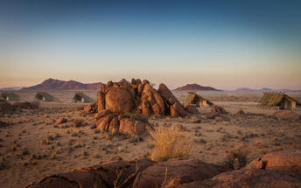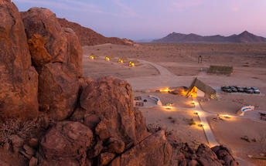

|  |
| --- |
| Directions - Swakopmund Sands Hotel to Desert Quiver Camp |
| **Distance:** 343.09km **Travel Time:** 4:20 hours |
| **GPS co-ordinates for Desert Quiver Camp:** S 24° 29' 8.520" E 15° 50' 15.540" |
| * Head west toward Am Zoll/Strand St (23 m)http://schemas.openxmlformats.org/drawingml/2006/picture * Turn right onto Am Zoll/Strand St (0.2 km) * Turn right onto Rhode Allee (0.6 km) * Turn right onto Nathaniel Maxuilili/B2 (31.3 km) * Continue onto B2 (0.6 km) * At the roundabout, take the 1st exit onto C14/M36. Continue to follow C14 (230 km) * Turn right onto C19 (71.1 km) * Turn right onto D826 (8.5 km) * Turn left. Destination will be on the left (0.5 km) |
| *Directions supplied by Google.* |

### Basis

Bed and Breakfast

## Day 7: Kalahari Red Dunes Lodge, Kalahari Namibia

### Kalahari Namibia

Spreading across Botswana, South Africa and Namibia, the Kalahari meaning 'the great thirst' is an exceptionally beautiful living desert. The landscape is characterised by a large semi-arid sandy savannah draped over a gently rolling inland sea of sand covering most of Botswana and large parts of Namibia and South Africa. It is also the last bastion of the indigenous San people with the modern world having enveloped all the other areas they once roamed. The Namibian portion is made up of red sands covered in thin, wispy, mostly golden grass and dotted with acacia trees and wide-ranging wildlife including gemsbok, impala, jackals and cheetah.

### Overnight: Kalahari Red Dunes Lodge [View iBrochure](https://wetu.com/iBrochure/43610_24103)

The Kalahari Red Dunes Lodge is situated in a vlei among the dunes on the western edge of the Kalahari, where the expansive Karoo desert meets the first red dunes of the Kalahari desert. This intimate lodge features uniquely and lovingly designed suites, each offering ample space and privacy. Guests are welcomed in a spacious reception building, and from there, a wooden walkway leads to the main building, which houses a restaurant with a cozy fireplace, a bar, an inviting lounge, and the "Kalahari Lounge" that boasts a fine selection of whiskey and hosts a billiard table. Additionally, there is a pool with a shaded area and comfortable loungers at the heart of the vlei.

Guests are encouraged to explore the Kalahari desert by following the well-marked hiking trails, biking, or participating in nature drives offered in the morning or afternoon.

For a deeper experience of the African Savannah's vastness, guests can embark on the 2- or 3-day TRANS KALAHARI WALK. This guided hike traverses desert-like landscapes teeming with giraffes, zebras, and antelopes, culminating in an overnight stay in the Dunes Camp nestled in the reserve.

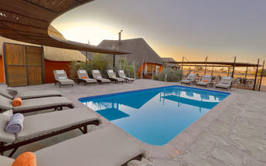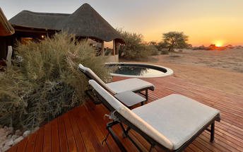

### Activities

|  |
| --- |
| Dead Vlei |

#### Dead Vlei

This ancient clay pan was once an oasis, studded with acacias and fed by a river that suddenly changed course, leaving the earth to dry up along with the trees it previously supported. So dry were the climatic conditions that the trees never decomposed – instead they were entirely leached of moisture so that today, 900 years later, they remain as desiccated, blackened sentinels dotting the pan’s cracked surface. Surrounded by the red-pink dunes of the Namibia Desert, they create a surreal spectacle that is a photographer's dream.

|  |
| --- |
| Directions - Desert Quiver Camp to Kalahari Red Dunes Lodge |
| **Distance:** 292.28km **Travel Time:** 3:42 hours |
| **GPS co-ordinates for Kalahari Red Dunes Lodge:** S 24° 05' 25.440" E 17° 38' 47.340" |
| * Head west toward D826 (0.5 km)http://schemas.openxmlformats.org/drawingml/2006/picture * Turn right onto D826 (8.5 km) * Turn right onto C19/M36. Continue to follow C19 (128 km) * Slight right to stay on C19 (7.7 km) * Turn left onto C14 (18.7 km) * Turn right onto C19 (13.5 km) * Turn left onto C21 (106 km) * Turn right onto B1 (7.1 km) * Turn left onto Kalahari Red Dunes Lodge Zuwegung (3.0 km) |
| *Directions supplied by Google.* |

### Basis

Dinner, Bed and Breakfast

## Day 8: End of Itinerary

|  |
| --- |
| Directions - Kalahari Red Dunes Lodge to Hosea Kutako International Airport [WDH] |
| **Distance:** 242.85km **Travel Time:** 2:50 hours |
| **GPS co-ordinates for Hosea Kutako International Airport [WDH]:** S 22° 29' 12.534" E 17° 27' 47.126" |
| * Head south toward B6http://schemas.openxmlformats.org/drawingml/2006/picture * Turn right onto B6 * Turn left onto Jan Jonker * Slight left * Continue onto Robert Mugabe Ave * At the roundabout, take the 2nd exit * At the roundabout, take the 3rd exit onto Sean McBride * Turn left onto Frankie Fredericks Street * Slight left toward Rehobother Rd/B1 * Slight left onto Rehobother Rd/B1Continue to follow B1 * Turn left onto Kalahari Red Dunes Lodge Zuwegung |

### Basis

Bed and Breakfast

### Urgent Contact Numbers

|  |  |  |  |
| --- | --- | --- | --- |
| **Company Name** | **Telephone** | **Email Address** | **Contact Person** |
| U Xplore Tours and Safaris | +264818100755 | barbara.hanekom@gmail.com | Barbara Hanekom |