

# Xplore 12 Days Namibia VIP -South

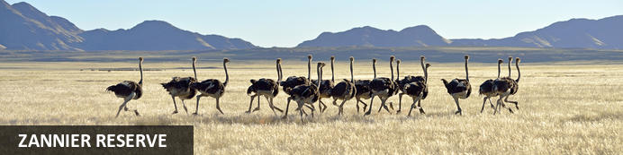

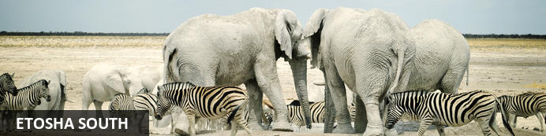

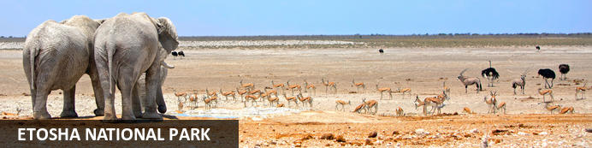

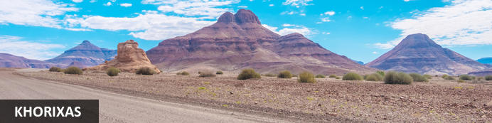

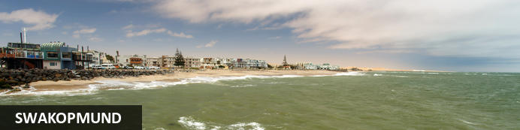

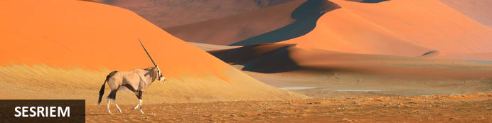

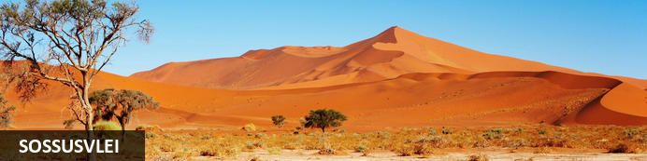

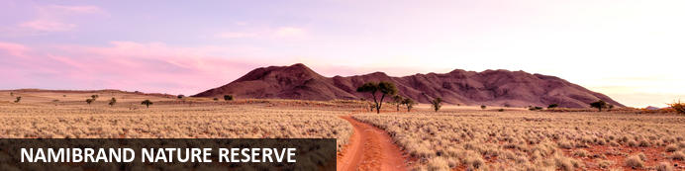

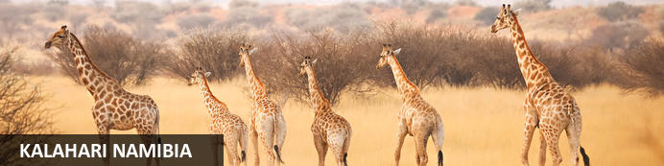

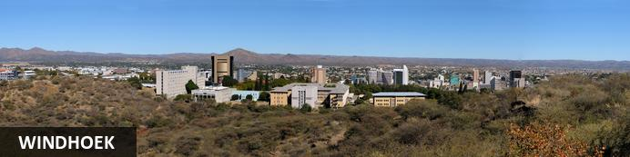

# Xplore 12 Days Namibia VIP -South

*Zannier Reserve - Etosha South - Etosha National Park - Khorixas - Swakopmund - Sesriem - Sossusvlei - NamibRand Nature Reserve - Kalahari Namibia - Windhoek*  
*12 Days / 11 Nights*  
*0 Persons*  
*Date of Issue: 25 February 2025*

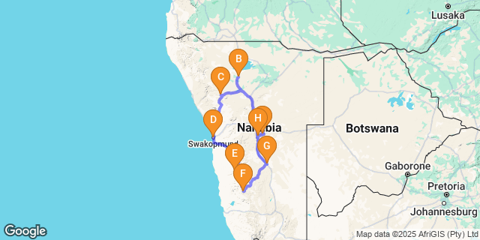

# [Click here to view your Digital Itinerary](https://wetu.com/Itinerary/Landing/EC2286EF-4EC9-4210-9A92-37BD8CAAB0E2)

## Introduction

|  |  |  |  |  |
| --- | --- | --- | --- | --- |
| **Start** | **Accommodation** | **Destination** | **Basis** | **Duration** |
| Day 1 | [Zannier Omaanda](https://wetu.com/iBrochure/43610_137613) | Zannier Reserve | D,B&B | **1 Night** |
| Day 2 | [Etosha Oberland Lodge](https://wetu.com/iBrochure/43610_201088) | Etosha South | D,B&B | **1 Night** |
| Day 3 | [Lodge Damaraland](https://wetu.com/iBrochure/43610_312689) | Khorixas | D,B&B | **1 Night** |
| Day 4 | Swakop Strand Apartments | Swakopmund | B&B | **2 Nights** |
| Day 6 | Dead Valley Lodge Morning Sossusvlei Excursion and Sesriem Canyon | Sesriem | D,B&B | **2 Nights** |
| Day 8 | [Zannier Sonop](https://wetu.com/iBrochure/43610_137615) | NamibRand Nature Reserve | D,B&B | **2 Nights** |
| Day 10 | [Kalahari Red Dunes Lodge](https://wetu.com/iBrochure/43610_24103) | Kalahari Namibia | D,B&B | **1 Night** |
| Day 11 | [River Crossing Lodge](https://wetu.com/iBrochure/43610_21619) | Windhoek | D,B&B | **1 Night** |

**Key**  
B&B: Bed and Breakfast  
D,B&B: Dinner, Bed and Breakfast

## Day 1: Zannier Omaanda, Zannier Reserve

### Zannier Reserve

Situated just 30 minutes east of Namibia's Windhoek International airport, Zannier Reserve stretches for 900 square kilometres. It is known for its scenic savanna-covered landscapes inhabited by a vast variety of wildlife. Commonly spotted species include: leopard, giraffe, warthog, antelope, ostrich and jackal. It is also home to the Shiloh Wildlife Sanctuary which provides a refuge for injured or abandoned rhinos and elephants. Visitors can look forward to spotting an array of wildlife, soaking up the beautiful views, and enjoying a guided safari to track the animals.

### Overnight: Zannier Omaanda [View iBrochure](https://wetu.com/iBrochure/43610_137613)

Omaanda, meaning rhinoceros in Oshiwambo, is a five-star lodge set within the Zannier Reserve by N/a’an ku sê, an incredible private animal conservation reserve of 9000 hectares in the countryside surrounding Windhoek. Overlooking the boundless savannah, the lodge offers 15 comfortable round thatched huts, paying tribute to the traditional architecture of Ovambo. It also features a restaurant and a cosy bar, overlooking a heated infinity pool. A spa and a boma complete the lodge facilities, offering a typically local place to meet and mingle by the fire. For safety reasons Omaanda only welcome children from 6 years onwards. The close proximity to Windhoek and the International Airport make Omaanda the perfect choice for the first and last nights of guest's stay in Namibia, promising a locally authentic experience.

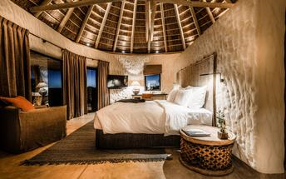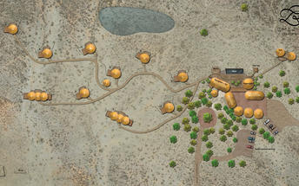

|  |
| --- |
| Directions - Hosea Kutako International Airport [WDH] to Zannier Omaanda |
| **Distance:** 50.25km **Travel Time:** 54 minutes |
| **GPS co-ordinates for Zannier Omaanda:** S 22° 27' 3.440" E 17° 24' 20.500" |
| * Exit the airport and turn right onto B6 road Detmont to Windhoek (West direction)http://schemas.openxmlformats.org/drawingml/2006/picture * After 9.5 km, turn right onto the D1510 (gravel road) * After 8.45 km, turn right onto M53 at the four ways intersection (gravel road) * After 9 km, you have reached the Omaanda lodge gate on the right hand side |

### Basis

Dinner, Bed and Breakfast

## Day 2: Etosha Oberland Lodge, Etosha South

### Etosha South

Located just south of the boundary of Etosha National Park in northwestern Namibia, Etosha South makes up the southern region of this wild paradise. The area is comprised of a collection of world class private game reserves. The national park can be accessed via the southern entrance at Andersson’s Gate. Visitors can catch a glimpse of a variety of wildlife including: lion, giraffe, elephant, white and black rhino, and a multitude of plains game. Popular activities include: enjoying an open 4x4 safari with an expert guide, half day or full day drives with the option of a picnic lunch with wine on the full day game drive.

### Overnight: Etosha Oberland Lodge [View iBrochure](https://wetu.com/iBrochure/43610_201088)

The lodge’s hallmarks are luxury and plenty of privacy. This remarkable place is superbly suited for safari excursions into Etosha. The main building is surrounded by large, ancient mopane trees in a wild, but park-like setting. Upon entering the lobby with the bar and spacious seating areas, the eye is drawn through the open building to the vast savannah, where often enough the first animals can be spotted right then. The large infinity pool also offers fantastic views of the open plain in front of the lodge and the two waterholes. The best spot to enjoy the sunset with a drink of your choice. After that we will treat you to a delicious 5-course dinner in our restaurant.

Our spacious chalets have been integrated into nature with loving care. They are placed so far apart and aligned so cleverly, that there is no sign of a neighbor. As a result, the rooms offer a high degree of privacy and unobstructed views of the savannah. The ingredients for a relaxed sojourn are 75 m² of living space, tasteful natural furnishings and colors, air conditioning and Wi-Fi in the room, minibar, tea and coffee station, and above all the incredible view. Great attention to detail rounds off the experience.

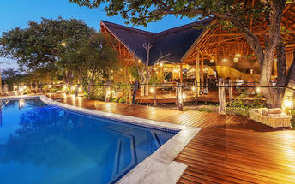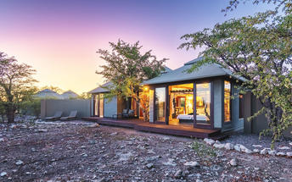

### Activities

|  |
| --- |
| Etosha Pan |

#### Etosha Pan

Aeons ago, Etosha Pan was the bed of a vast lake; today what remains is a glittering, silvery-green salt pan that stretches across roughly 5000 square kilometres. Etosha is protected by the Etosha Pan National Park surrounded by savannah plains and woodlands supporting large herds of elephants. When dry, the pan sustains little life except for the algae that gives it its distinctive colour, and migratory birds that use it as a pit stop, but with heavy rain it becomes a shallow lake where flamingos breed, pelicans wade and feed, and a variety of mammal species come to quench their thirst, including leopards, lions, white rhinos, hunting dogs and antelopes.

|  |
| --- |
| Directions - Zannier Omaanda to Etosha Oberland Lodge |
| **Distance:** 456.05km **Travel Time:** 4:49 hours |
| **GPS co-ordinates for Etosha Oberland Lodge:** S 19° 22' 12.200" E 15° 58' 55.200" |
| * Head west (1.5 km)http://schemas.openxmlformats.org/drawingml/2006/picture * Turn left (0.6 km) * Turn right (1.2 km) * Turn left (0.4 km) * Turn right (0.8 km) * Turn left onto M53 (17.2 km) * Turn right onto B6 (16.3 km) * Turn right onto Sam Nujoma Dr (1.8 km) * Turn right onto Nelson Mandela Ave (3.2 km) * Turn right onto Robert Mugabe Ave (1.7 km) * At the roundabout, take the 2nd exit (0.2 km) * Continue straight (0.1 km) * Continue onto B1 (0.8 km) * Turn right onto the ramp to A1 (0.4 km) * Continue onto A1 (69.9 km) * Continue onto B1 (173 km) * At the roundabout, take the 1st exit onto Lang Street (2.4 km) * Turn left onto B1/C38. Continue to follow C38 (159 km) * Turn right (22 m) * Turn right (0.6 km) * Turn left (3.2 km) * Turn right (0.2 km) * Turn left at the 1st cross street. Destination will be on the left (2.3 km) |
| *Directions supplied by Google.* |

### Basis

Dinner, Bed and Breakfast

## Day 3: Lodge Damaraland , Khorixas

### Khorixas

This small town in the Southern Kunene Region of Namibia was once the capital of Damaraland and is home to around 6000 inhabitants, most of whom are from the Damara ethnic group. While the tiny town itself provides travel necessities at the local supermarket, bank, and petrol station, the surrounding area is a nature lover’s paradise with a variety of tourist attractions including the bizarre Welwitschia mirabilis at Burnt Mountain, rare stone formations, the petrified forest, ancient rock engravings and as well as many fascinating geological phenomena (make sure to see the 'Organ Pipes'). Khorixas is the epitome of a Namibian rural town. It marches to a slow African rhythm and its wonderfully friendly locals offer a warm welcome to all guests.

### Overnight: Lodge Damaraland [View iBrochure](https://wetu.com/iBrochure/43610_312689)

Conveniently located within easy traveling distance of the Petrified Forest and Twyfelfontein, Lodge Damaraland boasts stylish architecture and carefully selected interiors, ensuring personalized service.  
  
Stay in air-conditioned luxury amidst the breathtaking mountain views of the Arid Eden Route.  
  
Our lodge promises not only luxury but also exceptional experiences. Embark on a guided visit to a local Himba village for an enriching cultural encounter, or take a guided activity to see the majestic desert-adapted elephants in their natural habitat.  
  
After a long day exploring nature, cool down in our beautiful pool or indulge in a relaxing massage from our skilled inhouse Spa therapists, who use authentic African Spa products.  
  
The lodge also features free WiFi, a bar with stunning views, and an evening Boma Fire where you can unwind with a sundowner drink before savoring delicious meals in our restaurant. Each room includes a private bathroom with a shower, free toiletries, a hairdryer, coffee & tea facilities, and bathrobes. For your peace of mind, we provide 24-hour secure parking, close to your room.

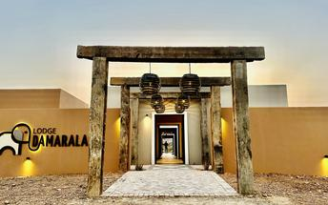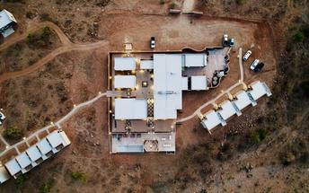

### Activities

|  |
| --- |
| Etosha Pan |
| Omapha Himba Village |

#### Etosha Pan

Aeons ago, Etosha Pan was the bed of a vast lake; today what remains is a glittering, silvery-green salt pan that stretches across roughly 5000 square kilometres. Etosha is protected by the Etosha Pan National Park surrounded by savannah plains and woodlands supporting large herds of elephants. When dry, the pan sustains little life except for the algae that gives it its distinctive colour, and migratory birds that use it as a pit stop, but with heavy rain it becomes a shallow lake where flamingos breed, pelicans wade and feed, and a variety of mammal species come to quench their thirst, including leopards, lions, white rhinos, hunting dogs and antelopes.

#### Omapha Himba Village

Omapha Himba Village in Etosha South, Namibia, is home to the indigenous Himba tribe, who are half-nomadic people. The people are famous for maintaining the traditional way of life of their ancestors up to recent times. External influences have not polluted them, and this reflects in the way they dress, cook, trade, interact and live. An array of wildlife can be seen roaming freely close to the village. Guided tours are offered, and guests can look forward to exploring the village in its natural environment.

|  |
| --- |
| Directions - Etosha Oberland Lodge to Lodge Damaraland |
| **Distance:** 229.35km **Travel Time:** 2:16 hours |
| **GPS co-ordinates for Lodge Damaraland :** S 20° 21' 31.538" E 14° 56' 46.691" |
| * Head northwest (2.3 km)http://schemas.openxmlformats.org/drawingml/2006/picture * Turn right (0.2 km) * Turn left (0.1 km) * Continue straight (3.7 km) * Turn left onto C38 (89.3 km) * Turn right onto C39 (133 km) * Turn right onto D2625 (0.9 km) |
| *Directions supplied by Google.* |

### Basis

Dinner, Bed and Breakfast

## Day 4: Swakop Strand Apartments, Swakopmund

### Swakopmund

Set along Namibia's spectacularly scenic coast, the seaside town of Swakopmund is known for its wide-open avenues, colonial architecture, and its surrounding otherworldly desert terrain. Founded in 1892 as the main harbour for German South-West Africa, Swakopmund is often described as being more German than Germany. Now a seaside resort town, Swakopmund is the capital of the Skeleton Coast tourism area and has plenty to keep visitors happy. The quirky mix of German and Namibian influences, adventure options, laid-back atmosphere and cool sea breeze make it a very popular Namibian destination. Visitors can look forward to a number of exciting activities including: quad biking, horse riding, paragliding, fishing, sightseeing and fascinating desert tours.

### Overnight: Swakop Strand Apartments

Two Self Catering apartments on the beachfront, in walking distance from the Aquarium and Jetty.

Both two bedroom units can sleep 4 adults or two parents with two children, ideal for mall families. Large and secure garage parking and in walking distance from the center of town. Each unit has an outside balcony with views of the surrounding dunes and ocean.

Both apartments have two bed rooms, each with two single ¾ beds, duvet and fitted sheet on the mattresses.

Apartment E has - 1 full sharing bathroom upstairs, 1 guest toilet next to the living area & 1 guest toilet on the lower level. Two outside balconies. Single garage with remote control door.

Apartment B - 1 full en-suit bathroom in main room and 1 additional bathroom with shower & toilet next to the second room on the upper level. Living area and two balconies. One bathroom with shower & toilet on the lower level. Double garage with remote control door.

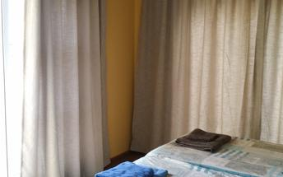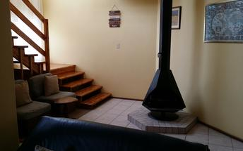

### Activities

|  |
| --- |
| Cape Cross Seal Colony |

#### Cape Cross Seal Colony

This colony of Cape Fur Seals is one of the largest in the world, home to approximately 80 000 to 100 000 of these so-called 'seals', which are in fact a species of sea lion. Day trips to the colony are offered and the seals can be viewed from a walkway at a distance of roughly 200 metres.

|  |
| --- |
| Directions - Lodge Damaraland to Swakop Strand Apartments |
| **Distance:** 319.51km **Travel Time:** 3:54 hours |
| **GPS co-ordinates for Swakop Strand Apartments:** S 22° 40' 31.049" E 14° 31' 18.778" |
| * Head south on D2625 toward C39 (0.9 km)http://schemas.openxmlformats.org/drawingml/2006/picture * Turn left onto C39 (10.3 km) * Turn right onto C35 (115 km) * Turn right onto C35/M76 (115 km) * Turn left onto C34/D2301. Continue to follow C34 (4.4 km) * Turn right to stay on C34 (0.6 km) * Turn left to stay on C34 (62.9 km) * Turn right to stay on C34 (7.9 km) * At the roundabout, take the 2nd exit (76 m) * Continue onto Henties Bay Rd/Nordring (0.6 km) * Turn right onto Mittel St/Tobias Hainyeko. Continue to follow Tobias Hainyeko (2.0 km) * Turn right onto Swakop St. Destination will be on the left (0.2 km) |
| *Directions supplied by Google.* |

### Basis

Bed and Breakfast

## Day 5: Swakop Strand Apartments, Swakopmund

### Activities

|  |
| --- |
| Sandwich Dune Tours and Safari Marine Dune Combo |

#### Sandwich Dune Tours and Safari Marine Dune Combo

Sandwich Dune Tours and Safari Marine Dune Combo offer adventurers the opportunity to explore the Atlantic Ocean onboard a catamaran cruise. Participants will be able to view marine animals such as pelicans, seals, old shipwrecks and Benguela dolphins. After the cruise, the dune drive tour will commence from Sandwich Dune Tours and Safari offices at Walvis Bay Waterfront. Here, participants will meet their guide, drive to Walvis Bay Lagoon, and continue to the large salt evaporation ponds. The tour will then finally head to Kuiseb Delta, a dry riverbed where animals such as springbok frequently seek water and food.

### Basis

Bed and Breakfast

## Day 6: Dead Valley Lodge Morning Sossusvlei Excursion and Sesriem Canyon, Sesriem

### Sesriem

As there is no accommodation at Sossusvlei, visitors to this desert wilderness are likely to end up staying at Sesriem, 65 kilometres away, where camps and lodges serve as a base from which to explore the dunes. Sesriem Canyon, a deep chasm carved through the rocks by water, is a striking natural feature of the area that is best explored on foot. Stony walls rise up sharply on both sides of the canyon, while birds roost in its crags and lizards dart along the ledges. The canyon’s name was coined when early settlers used it as a water source, using six lengths of leather (‘ses riem – six thongs) tied together to lower buckets into the water at the base of canyon.)

### Overnight: Dead Valley Lodge Morning Sossusvlei Excursion and Sesriem Canyon

The Dead Valley Lodge is situated inside the Namib–Naukluft Park, between the Sesriem campsite and Elim Dune, on the way to the world famous Sossusvlei. Guests can enjoy a scenic drive in the morning to Sossusvlei and Sesriem Canyon, taking in the region's towering red sand dunes, rugged mountain ranges, and arid desert savannahs.

|  |
| --- |
| Directions - Swakop Strand Apartments to Dead Valley Lodge Morning Sossusvlei Excursion and Sesriem Canyon |
| **Distance:** 347.18km **Travel Time:** 4:25 hours |
| **GPS co-ordinates for Dead Valley Lodge Morning Sossusvlei Excursion and Sesriem Canyon:** S 24° 28' 54.241" E 15° 47' 37.878" |
| * Head east on Swakop St toward Tobias Hainyeko (0.2 km)http://schemas.openxmlformats.org/drawingml/2006/picture * Turn left onto Tobias Hainyeko (0.1 km) * Turn right onto Rhode Allee (0.3 km) * Turn right at the 2nd cross street onto Nathaniel Maxuilili/B2 (31.3 km) * Continue onto B2 (0.6 km) * At the roundabout, take the 1st exit onto C14/M36. Continue to follow C14 (230 km) * Turn right onto C19 (71.1 km) * Turn right onto D826 (11.9 km) * Continue straight (0.8 km) * Turn right (0.6 km) * Turn left (84 m) |
| *Directions supplied by Google.* |

### Basis

Dinner, Bed and Breakfast

## Day 7: Dead Valley Lodge Morning Sossusvlei Excursion and Sesriem Canyon, Sesriem

### Activities

|  |
| --- |
| Dead Vlei |

#### Dead Vlei

This ancient clay pan was once an oasis, studded with acacias and fed by a river that suddenly changed course, leaving the earth to dry up along with the trees it previously supported. So dry were the climatic conditions that the trees never decomposed – instead they were entirely leached of moisture so that today, 900 years later, they remain as desiccated, blackened sentinels dotting the pan’s cracked surface. Surrounded by the red-pink dunes of the Namibia Desert, they create a surreal spectacle that is a photographer's dream.

### Basis

Dinner, Bed and Breakfast

## Day 8: Zannier Sonop, NamibRand Nature Reserve

### NamibRand Nature Reserve

Spanning an area of 172,200 hectares and encompassing four distinct ecosystems, the NamibRand Reserve of southern Namibia is among the largest privately owned game parks in Southern Africa. Founded to conserve the unique environment and wildlife species of the Namib Desert, the park’s mix of dunes, mountains, rocky outcrops, sandy flats, and gravel plains provides habitats for a diversity of mammals, including hyenas, jackals, foxes, antelopes, and various wild cats. A plethora of bird species, reptiles, insects, and frogs also have their home here, alongside an array of plant species. Discover the mysterious ‘fairy circles’, unexplained bare patches in the sand, or enjoy a night of sublime stargazing - having been named Africa’s first International Dark Sky Reserve, it is one of the least light-polluted areas in the world.

### Overnight: Zannier Sonop [View iBrochure](https://wetu.com/iBrochure/43610_137615)

Sonop is a luxurious tented camp nestled at the Southern extremity of the Namib desert, in the Karas region. Designed as a refined British colonial experience from the 1920’s, this out-of-the-ordinary lodge offers a perfect retreat in a stunning panoramic desert landscape. Constructed on top of boulders, the ten spacious tents aim to offer a unique journey through time. Richly furnished with antiques made of fine materials, colourful carpets and precious wood, they are an invitation to live the life of yesteryear’s wealthy explorers. A sophistication that contrasts with the simplicity of the endless surroundings. At Sonop everything is orientated towards the desert’s richness: all views are awe-inspiring and a large list of adventures allow guests to admire the desert’s genuine beauty at leisure. Every evening guests are invited to enjoy an opulent gastronomic experience, where silverware and candelabras set the mood, enhanced by black-tie and white gloves service. Flawless service and attention to detail characterise all facilities of the camp.

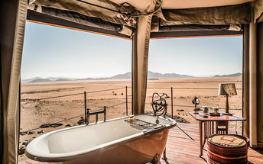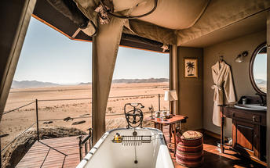

|  |
| --- |
| Directions - Dead Valley Lodge Morning Sossusvlei Excursion and Sesriem Canyon to Zannier Sonop |
| **Distance:** 168.71km **Travel Time:** 2:28 hours |
| **GPS co-ordinates for Zannier Sonop:** S 25° 29' 55.110" E 16° 10' 55.450" |
| * Head east (84 m)http://schemas.openxmlformats.org/drawingml/2006/picture * Turn right (0.6 km) * Turn left (0.8 km) * Turn right onto C27 (96.2 km) * Turn right onto D831 (40.6 km) * Turn right onto C27 (23.5 km) * Turn right onto D707. Destination will be on the left (6.9 km) |
| *Directions supplied by Google.* |

### Basis

Dinner, Bed and Breakfast

## Day 9: Zannier Sonop, NamibRand Nature Reserve

### Basis

Dinner, Bed and Breakfast

## Day 10: Kalahari Red Dunes Lodge, Kalahari Namibia

### Kalahari Namibia

Spreading across Botswana, South Africa and Namibia, the Kalahari meaning 'the great thirst' is an exceptionally beautiful living desert. The landscape is characterised by a large semi-arid sandy savannah draped over a gently rolling inland sea of sand covering most of Botswana and large parts of Namibia and South Africa. It is also the last bastion of the indigenous San people with the modern world having enveloped all the other areas they once roamed. The Namibian portion is made up of red sands covered in thin, wispy, mostly golden grass and dotted with acacia trees and wide-ranging wildlife including gemsbok, impala, jackals and cheetah.

### Overnight: Kalahari Red Dunes Lodge [View iBrochure](https://wetu.com/iBrochure/43610_24103)

The Kalahari Red Dunes Lodge is situated in a vlei among the dunes on the western edge of the Kalahari, where the expansive Karoo desert meets the first red dunes of the Kalahari desert. This intimate lodge features uniquely and lovingly designed suites, each offering ample space and privacy. Guests are welcomed in a spacious reception building, and from there, a wooden walkway leads to the main building, which houses a restaurant with a cozy fireplace, a bar, an inviting lounge, and the "Kalahari Lounge" that boasts a fine selection of whiskey and hosts a billiard table. Additionally, there is a pool with a shaded area and comfortable loungers at the heart of the vlei.

Guests are encouraged to explore the Kalahari desert by following the well-marked hiking trails, biking, or participating in nature drives offered in the morning or afternoon.

For a deeper experience of the African Savannah's vastness, guests can embark on the 2- or 3-day TRANS KALAHARI WALK. This guided hike traverses desert-like landscapes teeming with giraffes, zebras, and antelopes, culminating in an overnight stay in the Dunes Camp nestled in the reserve.

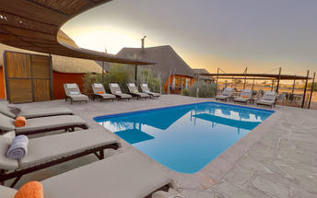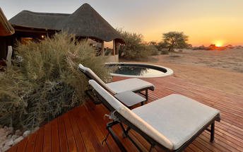

|  |
| --- |
| Directions - Zannier Sonop to Kalahari Red Dunes Lodge |
| **Distance:** 259.34km **Travel Time:** 3:19 hours |
| **GPS co-ordinates for Kalahari Red Dunes Lodge:** S 24° 05' 25.440" E 17° 38' 47.340" |
| * Head northeast on D707 toward C27 (6.9 km)http://schemas.openxmlformats.org/drawingml/2006/picture * Turn left onto C27 (23.5 km) * Turn right onto D826 (37.3 km) * Slight left onto D831 (15.5 km) * Continue straight onto D824 (11.0 km) * Turn left onto C14 (35.9 km) * Turn right onto C19 (13.5 km) * Turn left onto C21 (106 km) * Turn right onto B1 (7.1 km) * Turn left onto Kalahari Red Dunes Lodge Zuwegung (3.0 km) |
| *Directions supplied by Google.* |

### Basis

Dinner, Bed and Breakfast

## Day 11: River Crossing Lodge, Windhoek

### Windhoek

Situated in Central Namibia, the cosmopolitan city of Windhoek serves as the capital of the country. It is home to an international airport and a plethora of restaurants, shops, entertainment venues and accommodation options. The city is clean, safe and well-organised, with a colonial legacy that is reflected in its many German eateries and shops, and the widespread use of the German language. Windhoek has an interesting mix of historical architecture and modern buildings, many of which are worth a look, including the Alte Feste an old fort, the 1896 Christuskirche Christ Church, and the more contemporary Supreme Court.

### Overnight: River Crossing Lodge [View iBrochure](https://wetu.com/iBrochure/43610_21619)

“Feel the pulse of the city from the heart of the bushveld.” River Crossing is 5 km from Windhoek, situated on the airport road and only 5 minutes from the heart of Windhoek. The lodge is situated on top of a koppie on a pristine 6500 hectare reserve, offering unparalleled sunset views. River Crossing will allow you to rediscover the nuances of a bygone era of farm life and offers the discerning traveler all the modern comforts.

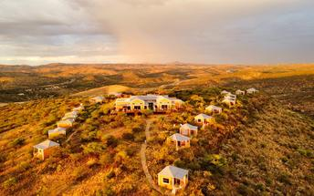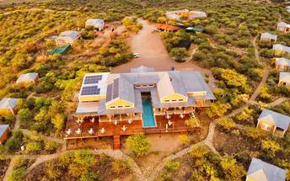

|  |
| --- |
| Directions - Kalahari Red Dunes Lodge to River Crossing Lodge |
| **Distance:** 207.17km **Travel Time:** 2:18 hours |
| **GPS co-ordinates for River Crossing Lodge:** S 22° 36' 9.863" E 17° 08' 32.486" |
| * Head southwest on Kalahari Red Dunes Lodge Zuwegung toward B1 (3.0 km)http://schemas.openxmlformats.org/drawingml/2006/picture * Turn right onto B1 (192 km) * Continue onto Mandume Ndemufayo Avenue/Rehobother Rd (0.7 km) * Turn right onto Sean McBride (1.8 km) * At the roundabout, take the 1st exit onto Robert Mugabe Ave (0.6 km) * At the roundabout, take the 3rd exit onto Hamutenya Wanahepo Ndadi St (3.3 km) * Turn left onto Michaelis Street (40 m) * Turn right at the 1st cross street onto Sam Nujoma Dr (0.4 km) * Turn right onto B6 (2.6 km) * Turn right (19 m) * Turn left (1.6 km) * Turn right (0.9 km) |
| *Directions supplied by Google.* |

### Basis

Dinner, Bed and Breakfast

## Day 12: End of Itinerary

|  |
| --- |
| Directions - River Crossing Lodge to Hosea Kutako International Airport [WDH] |
| **Distance:** 39.50km **Travel Time:** 36 minutes |
| **GPS co-ordinates for Hosea Kutako International Airport [WDH]:** S 22° 29' 12.534" E 17° 27' 47.126" |
| * Head northeast (0.8 km)http://schemas.openxmlformats.org/drawingml/2006/picture * Turn left (1.7 km) * Turn right onto B6 (34.5 km) * Turn left (0.6 km) * Turn right (0.6 km) * Slight left (0.2 km) * Turn leftDestination will be on the right (1.1 km) |

### Basis

Bed and Breakfast

### Urgent Contact Numbers

|  |  |  |  |
| --- | --- | --- | --- |
| **Company Name** | **Telephone** | **Email Address** | **Contact Person** |
| U Xplore Tours and Safaris | +264818100755 | barbara.hanekom@gmail.com | Barbara Hanekom |